Ordered semiconductor single- and coupled-

quantum dot structures grown on inverted pyramids

V. Troncale, K. F. Karlsson, M. Byszewski, E. Pelucchi, A.Rudra, D.Y. Oberli
and E. Kapon
Ecole Polytechnique Fédérale de Lausanne (EPFL)

Laboratory of Physics of Nanostructures
CH-1015 Lausanne, Switzerland

e-mail: Valentina.Troncale@epfl.ch

Semiconductor quantum dots (QDs) have attracted considerable interest because of their potential for application in experimental quantum information processing. In particular, the coupling of two QDs has been proposed as a means for generating entangled photons and realizing quantum bit operations. Essential requirements for such future device applications are the precise control over QD position and dimension, the accurate engineering of the energy levels and homogeneity of emission energies. Here we report relevant experimental observations performed on systems of ordered, single and double QD dot systems produced using self-limited OMCVD growth in inverted pyramids (see Fig. 1) [1].
At low temperature and low excitation power, the µPL spectrum of single QDs is dominated by exciton complexes (X, 2X, X⁺, X⁻) composed of electrons and holes in the ground state. Micro photoluminescence excitation (µPLE) spectra of X exhibit sharp resonances of excited states, on the high-energy side. Polarization-resolved µPL along the growth axis has been performed to further understand the character of the QDs excited states. We observed a very strong polarization anisotropy, different for the ground and excited state emission, respectively, and we identified several novel excitonic complexes, involving excited hole states.
We also explored the possibility of tuning two QD states into mutual resonance via a systematic study of double-dot pyramids, as a function of the dot separation and relative size (Fig. 1). Evidence of bonding and anti-bonding states for the coupled system (see Fig.2) was observed in µPL spectroscopy spectra of these structures. Their utilization for the formation of QD molecules and superlattices will be discussed.

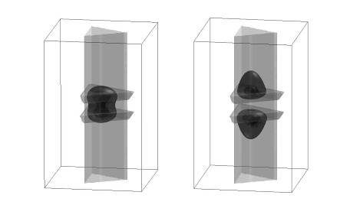
Fig.1. Double QDs in an inverted Fig.2. Bonding and anti-bonding
pyramid. states of a coupled QD system.

[1] M. H. Baier et al., Appl. Phys. Lett. 84, 1967 (2004).

